**A SMART SENSOR SYSTEM FOR SMOG MONITORING**

|  |  |
| --- | --- |
| Abstract – *Air pollution is the most effective pollution in the world. Where it is gradually increasing day by day. According to research in the year of 2021 India rank 5th place and more than 1.6 million deaths occurred due to air pollution. High level increase in air pollution caused* *risk of respiratory infections, dry throat, headache, chest pain, heart disease, asthma and lung cancer etc. We have implemented Smart Sensor System For Smog Monitoring that detects various poisonous gases such as Carbon Dioxide, Carbon Monoxide, Methane, LPG, Mercury, Sulphur Dioxide, Smoke, and Propane using Arduino UNO microchip ATmega328P with THINGSPEAK SERVER is used for Internet Of Things projects where data is been processed and analysed in real time , frequently used for prototyping and proof-of-concept systems. We have used sensors like MQ2, MQ135, MQ7 and DHT11. Air quality will show in parts per million. When the sensor value crossing more than the ppm value buzzer starts to beep.*  Keywords:  I. INTRODUCTION  Air Pollution caused in the areas of using fossil fuels for energy combustion releases a lot of sulphur dioxide into the atmosphere. Air pollution is also caused by carbon monoxide, which is generated when fossil fuels are burned inefficiently. Vehicle emissions, including those from trucks, cars, buses, and jeeps, harm the environment. These are the main producers of greenhouse gases, and they also make people sick. Farming Activities is the most dangerous chemicals released during agricultural operations is ammonia ,Insecticides, pesticides, and fertilisers damage the atmosphere by emitting dangerous substances. Industries and Factories is the primary source of carbon monoxide, organic compounds, hydrocarbons, and chemicals is industry and manufacturing. These are most important things which is lowering the quality of the air. According to a recent estimate, air pollution will probably shorten the lives of 40% of Indians by more than nine years. High levels of pollution affect more than 480 million people who live in central, eastern, and northern India. The National Clean Air Program (NCAP) of India seeks to cut pollution in the 102 cities | Real time Smog monitoring machine which is used to measure the quality of the air is it “FRESH AIR” or “POLLUATED AIR”. Cost effective machine and easy for installation which can be installed or setup in various location of the cities. IOT based open source microcontroller board ARDUINO UNO 8-bit microcontroller ATmega328P contains great features such as more instructions every cycle, more frequently, built-in control, flexibility & usability, adjustable pins, rapid start, additional flash memory, low voltage demand ,play and plug. USB connection and extra storage. Used 4 different sensors which is used to generate the data and send to the cloud server thingspeak. Thingspeak is an best platform which is used to store the sensors data with the interface of API key over an internet. After singed into the thingspeak account individual channels is been created for each different sensors , best user interface such as charts , graphs and collaborating app with web services. Once after the setup connections of channels are created and automatically data are visualised.      II. IMPLEMENTATION  Hardware Components   * ARDUINO UNO * BUZZER * LCD 16*2 * DHT11 * ESP8266 WIFI MODULE * MQ2 * MQ7 * MQ135 * BREADBOARD * JUMPER WIRES   Software Components   * ARDUINO IDE * THINGSPEAK |

|  |  |
| --- | --- |
| DHT11  MD135  MQ7  MQ2  BUZZER  ESP8266  LCD 16*2 | DHT11 VCC TO MQ135 VCC  DHT11 A0 TO ARDUINO UNO A3 PIN  DHT11 GND TO MQ135 GND  MQ135 VCC TO MQ7 VCC  MQ135 A0 PIN TO ARDUINO UNO A2 PIN  MQ135 GND TO MQ7 GND  MQ7 VCC TO MQ2 VCC  MQ7 A0 PIN TO ARDUINO UNO A1 PIN  MQ7 GND TO MQ2 GND  MQ2 VCC TO ARDUINO UNO 5V.V  MQ2 A0 PIN TO ARDUINO UNO A0 PIN  MQ2 GND TO ARDUINO UNO GND  POSITIVE(+) TO ARDUINO UNO GND’  NEGATIVE(-) TO ARDUINO UNO D8 PIN  ESP8266 GND TO ARDUINO UNO GND  ESP8266 TX TO ARDUINO UNO TX  ESP8266 VCC TO ARDUINO UNO 3.3V  ESP8266 RX TO ARDUINO UNO RX  ESP8266 RESET TO ARDUINO UNO GND  ESP8266 - CHEN 220oh TO VCC  ESP8266 – GPIO-0 TO GND  LCD VSS TO BREADBOARD GROUND BUS(-)  LCD VDD TO BREADBOARD POWER BUS(+)  POTENTIOMETER 10K INPUT(Vout) TO LCD VE  LCD RS TO ARDUINO UNO D12 PIN  LCD RW TO BREADBOARD GROUND BUS (-)  LCD ENABLE(E) TO ARDUINO UNO D11 PIN  LCD BACKLIGHT ANODE TO BREADBOARD GROUND BUS(-)  LCD BACKLIGHT CATHODE 220oh RESISTOR TO BREADBOARD GROUND BUS(+)  LCD D7 TO ARDUINO UNO D2 PIN  LCD D6 TO ARDUINO UNO D3 PIN  LCD D5 TO ARDUINO UNO D4 PIN  LCD D4 TO ARDUINO UNO D5 PIN |

|  |
| --- |
| 1. PIN DESCRIPTION |

B) HARDWARE COMPONETS DESCRIPTION

DHT11 – is a sensor which provides humidity values which is estimated in % percentage and (20 to 90% RH) temperature value which is estimated in Celsius (0 to 50 °C). Use a resistive humidity measurement component as well as an NTC temperature measurement component.

MQ135 – it’s a air quality gas sensor which can identify dangerous gases and smoke, including ammonia (NH3), sulphur (S), benzene (C6H6), and Carbon Dioxide.

MQ7 – it is mainly used to detect Carbon Monoxide. Cost effective, high range of parts per million values

MQ2 - A Metal Oxide Semiconductor it’s a type of gas sensor which is used primarily to identify various gases like methane, butane, LPG, smoke, etc.

Buzzer – It’s kind of beeper or alarm, when the sensor value crosses the threshold value then buzzer starts to beep. Once the smoke or gas level decreases automatically buzzer stop beeping.

LCD 16*2 – it’s used as an output device where all the sensors input data are converted into the output and displayed in the LCD.

ESP8266 – it’s a Wi-Fi module where arduino Uno get connected to the Wi-Fi, API key get activated and can easily upload, monitor and store the data into cloud by using open source THINGSPEAK.

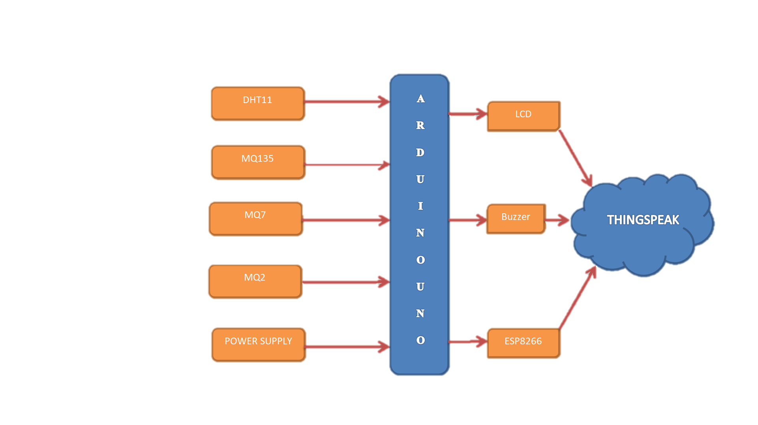

|  |
| --- |
| a) CIRCUIT DIAGRAM |

b) BLOCK DAIGRAM

|  |  |
| --- | --- |
| |  | | --- | |  | |

|  |  |
| --- | --- |
| THINGSPEAK: We can upload sensor data to the cloud using the IoT cloud platform called ThingSpeak. With MATLAB or other tools, we can also perform data analysis and data visualisation, as well as create our own apps. MathWorks runs the ThingSpeak platform. We must either log in to your current MathWorks Account or establish a new MathWorks Account in order to register for ThingSpeak. We can use THINGSPEAK for small iot projects, ThingSpeak is open source .We gather and store sensor data in the cloud with ThingSpeak's Web Service (REST API) and create Internet of Things apps. It is compatible with MATLAB, Raspberry Pi, and Arduino But that utilises a REST API and HTTP; We can compile all types of programming languages.  C) SOFTWARE COMPONENTS DESCRIPTION    C) THINGSPEAK MONITOR c)  ARDUINO IDE: An text editor for writing code as a message area, a text console, a toolbar with buttons, the Arduino Integrated Development Environment, even known as Arduino Software (IDE). It uploads program and communicate and connects to the Arduino hardware. Sketches are computer programmes. The programs are created in a text editor and saved as the.ino extension.  While compiling and uploading the code, the message console section shows DONE UPLOADING but if any error in code or port not selected it shows ERROR. |  |

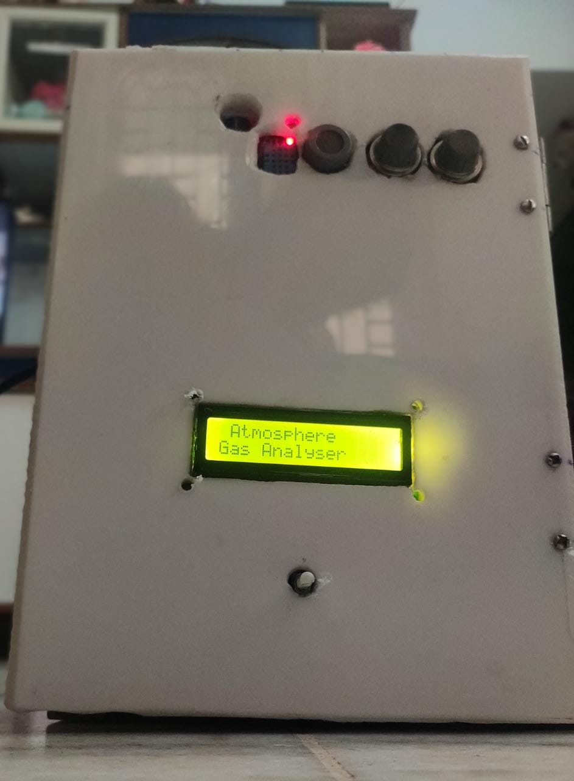 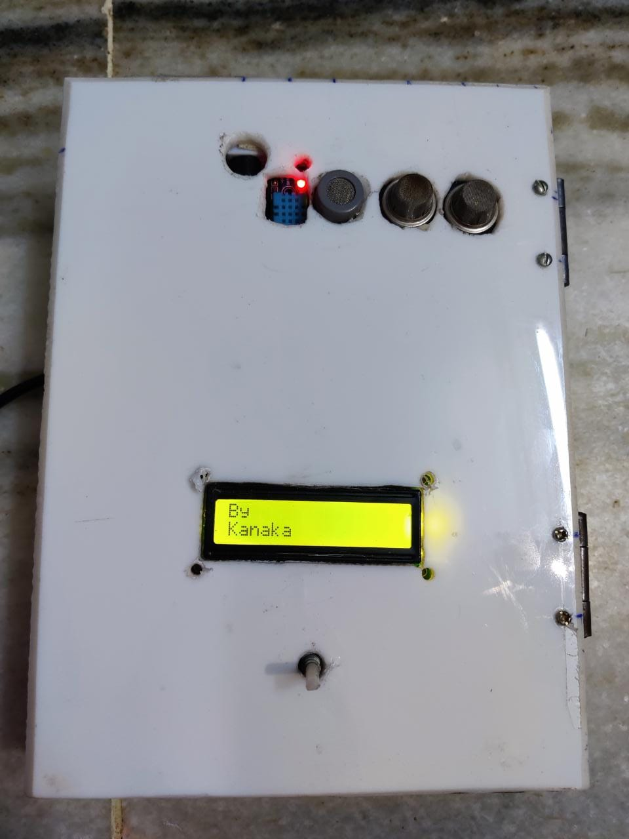

D) WORKING

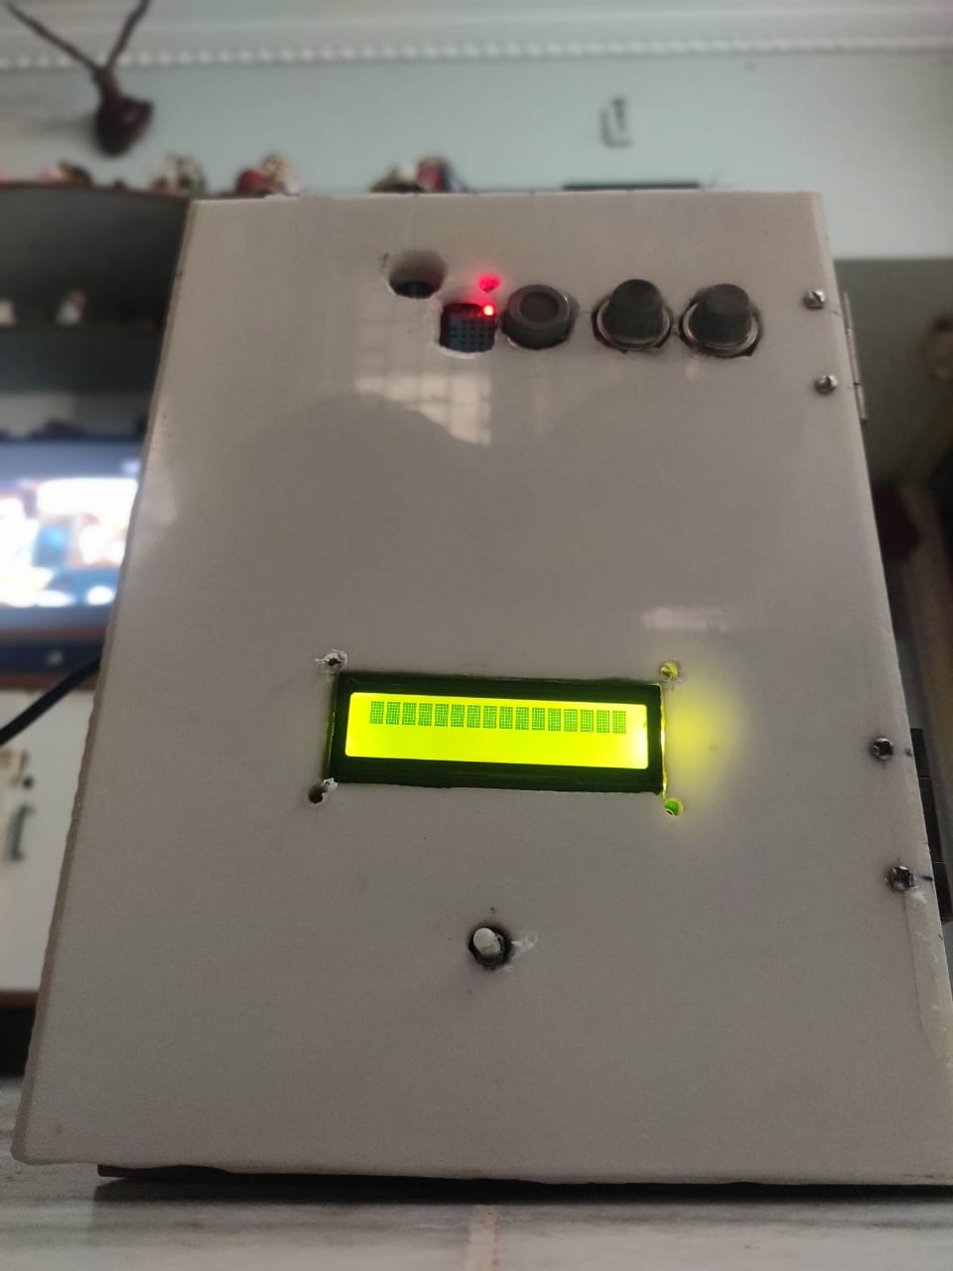 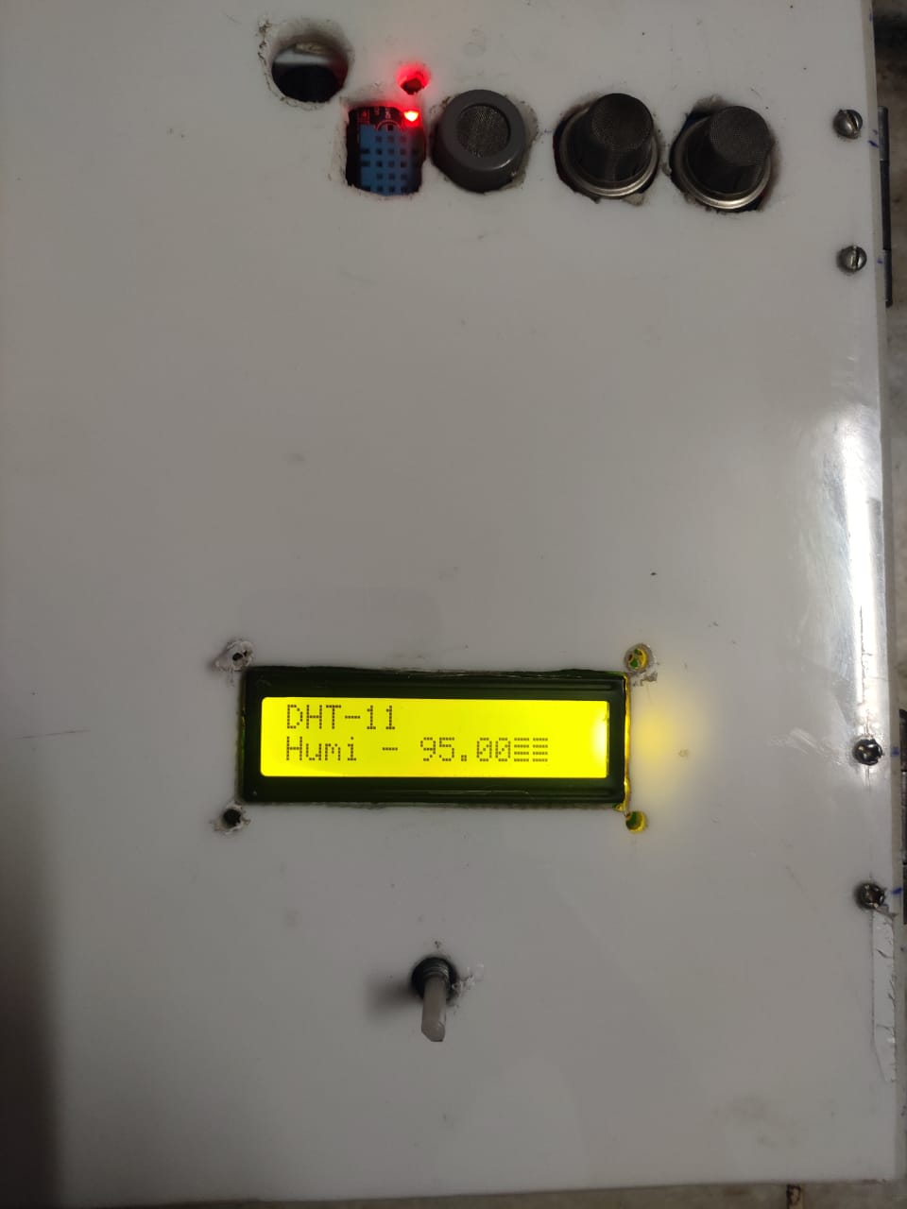

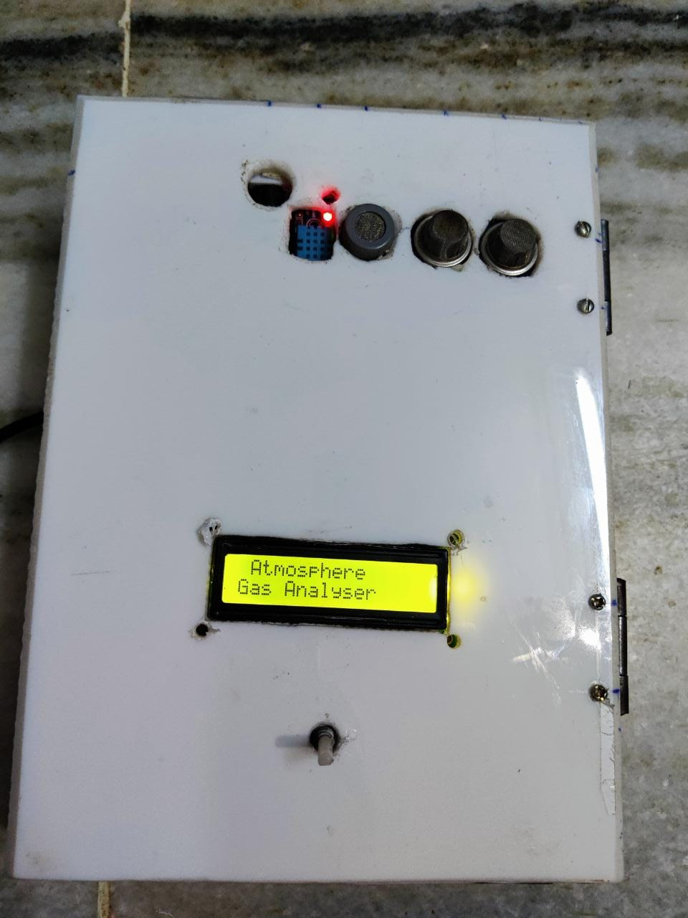

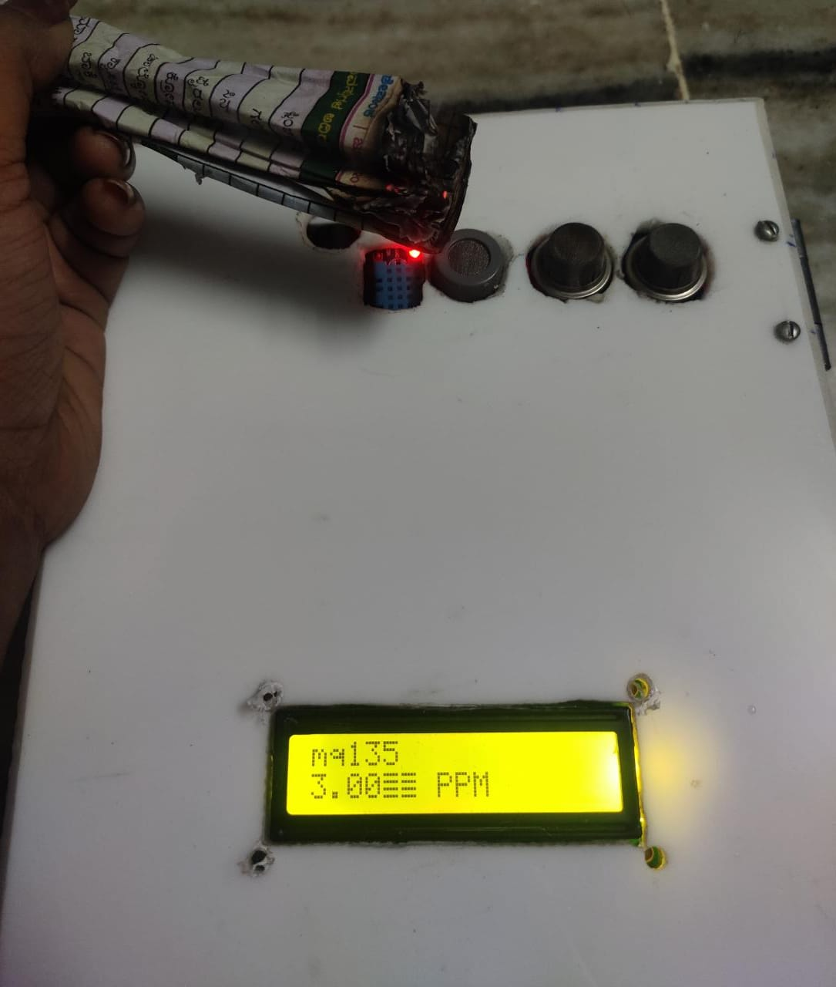

F) OUTPUT

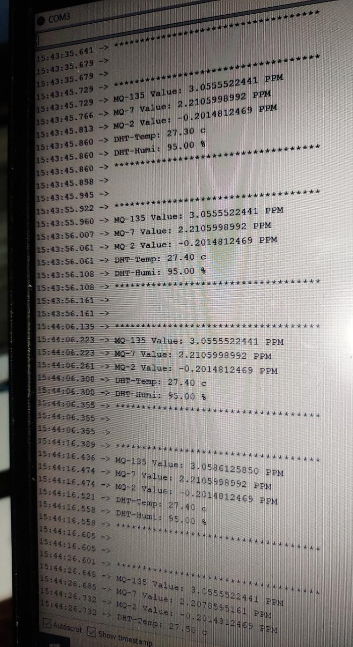

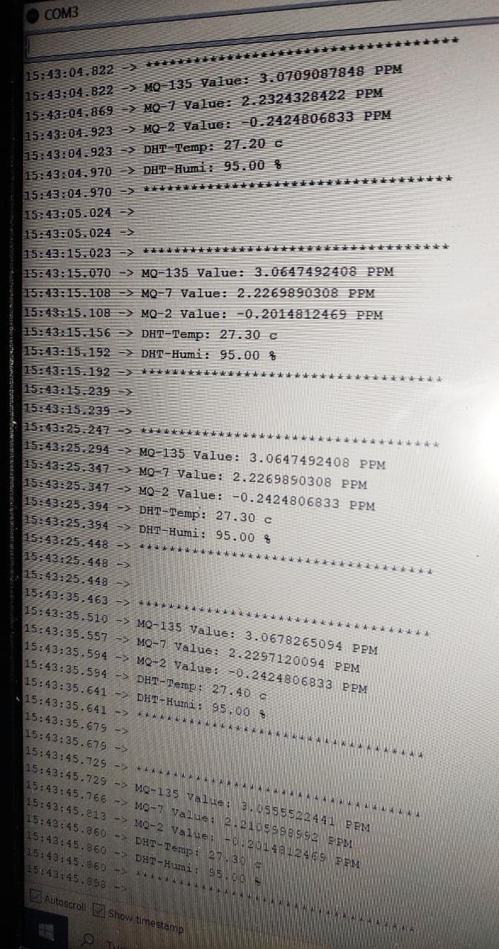

E) EXPERIMENTS

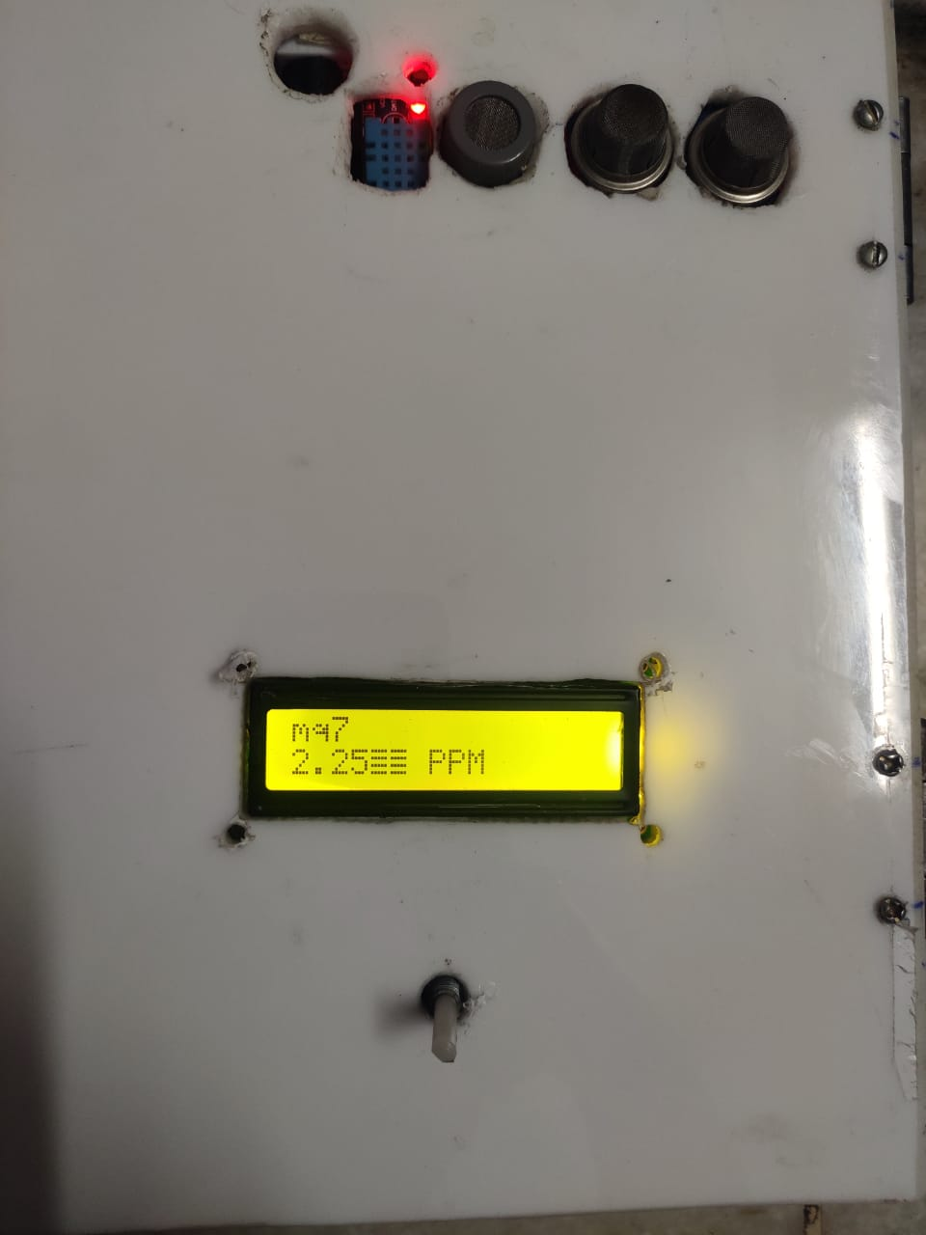

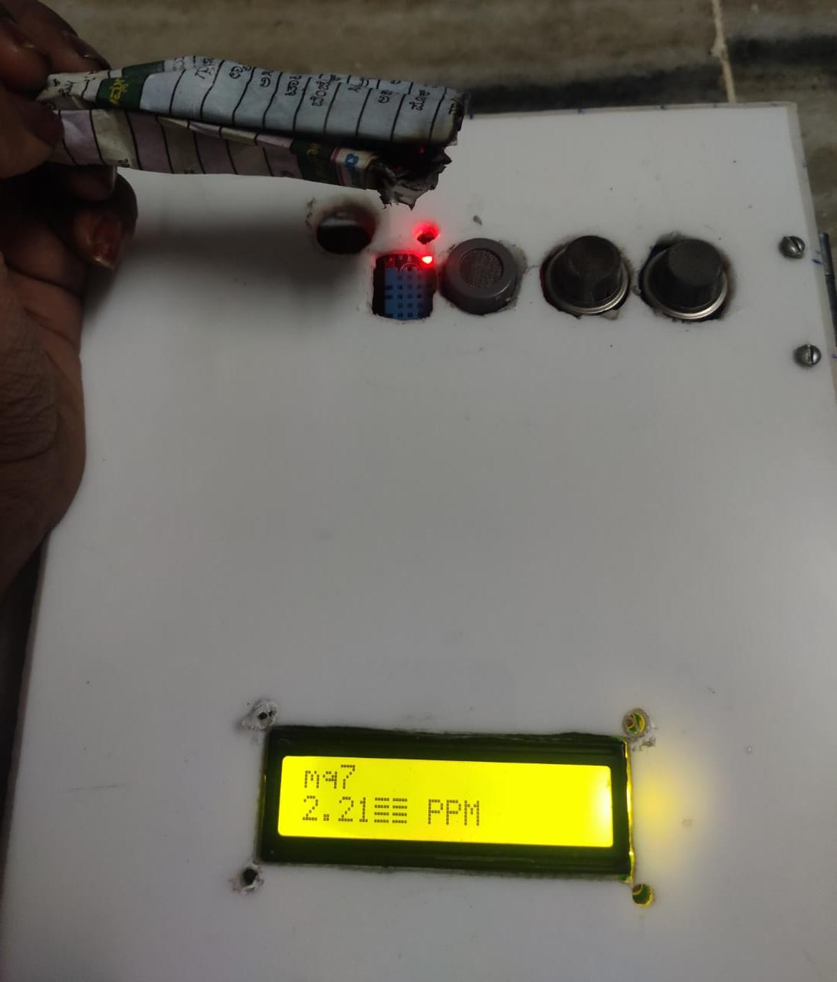

|  |
| --- |
| Wanted to take initiative and bring the change in the society where this device will be very useful for human’s and setup green environment by growing more plants and trees. Smog monitoring is an mini electronic monitoring device where it monitors all kind of poisonous gases such as carbon dioxide, carbon monoxide, methane, LPG, propane, sulphur, ammonia, butane, nitrogen dioxide. Cost effective and Portable device were we can setup in commercial and industrial purpose. Must stop burning of wastage, put layers of filters in the factory funnels, use public transport rather than using individual vehicles etc. Arduino Uno board is an best choice for iot projects. Could have taken one gas sensor for monitoring but we have used 4 different sensors because each sensor as different feature, ppm value and percentage varies. Data is stored and monitored through serial monitor in arduino ide and THINGSPEAK cloud. Coding in arduino ide was very simple were library files, example programs, compiling, uploading sketches is easier. By using this device can prior understand the changes in the air and take precautions according to it. Rather than cutting of the trees try to grow more plants and keep our health healthy.  III. CONCLUSION |

IV. FUTURE SCOPE

Want to upgrade the device by using Raspberry Pi board because it has great features such as fast processor, support all different programming codes etc. Create on and off automatic sensor when air getting polluted device automatically gets ON and when air is getting fresh automatically gets OFF. Create a software application where users can easily monitor through an app.

=

THANKYOU